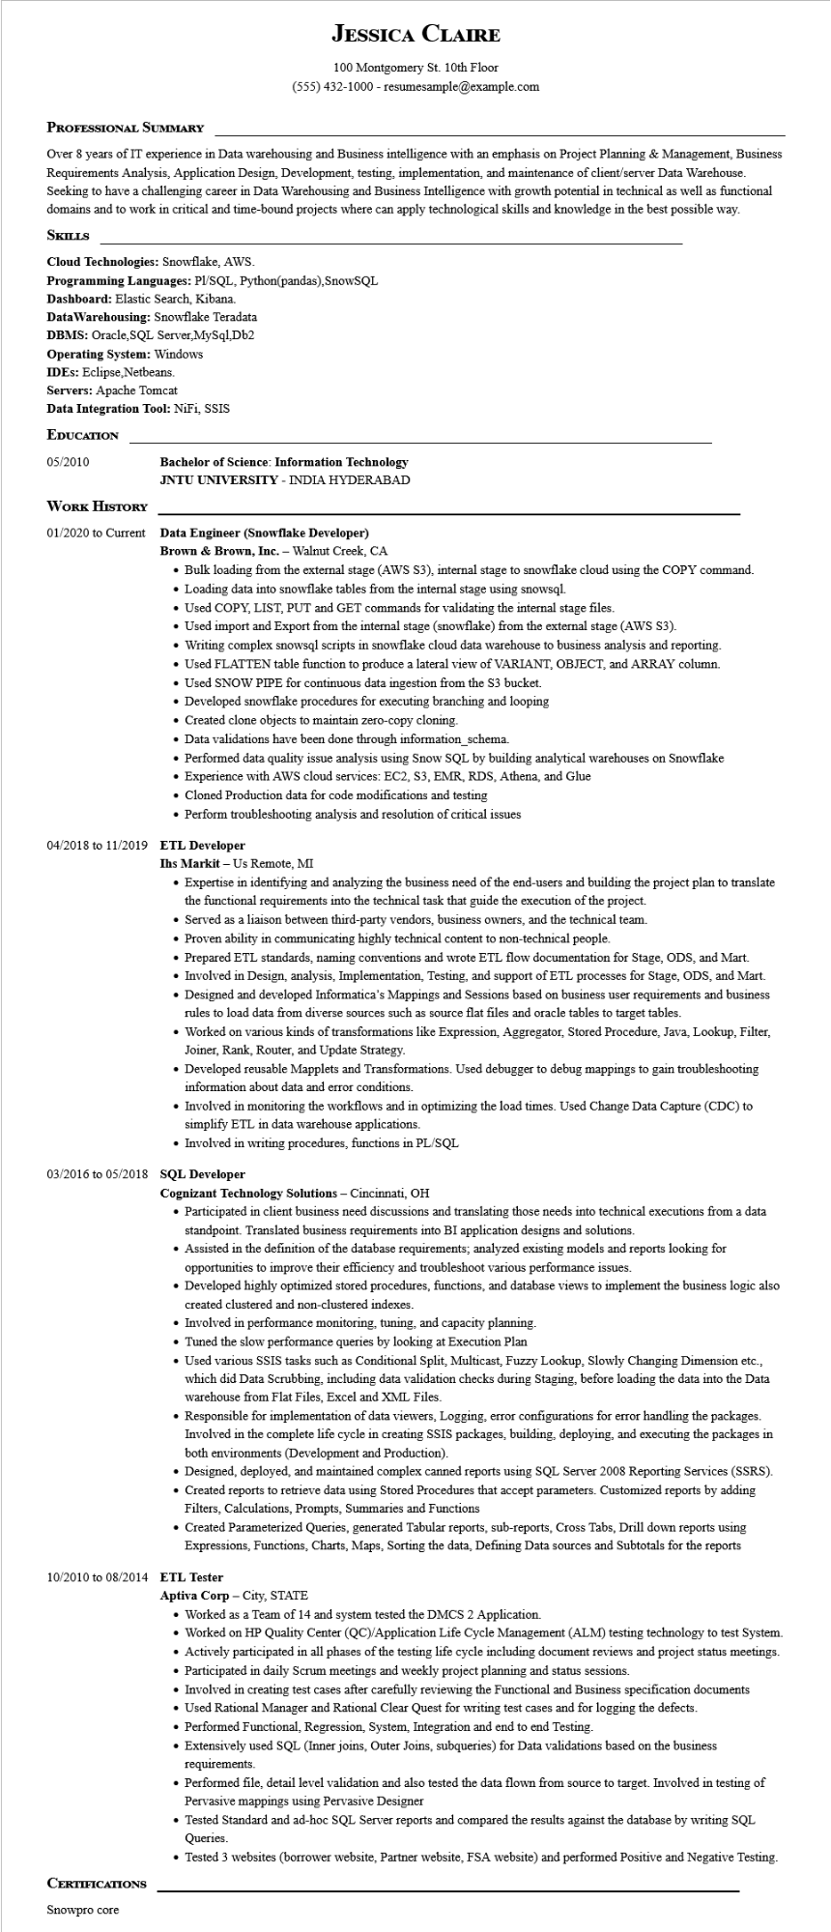
JESSICA CLAIRE
100 Montgomery St. 10th Floor
(555) 432-1000 - resumesample@example.com
PROFESSIONAL SUMMARY
Over 8 years of IT experience in Data warehousing and Business intelligence with an emphasis on Project Planning & Management, Business Requirements Analysis, Application Design, Development, testing, implementation, and maintenance of client/server Data Warehouse. Seeking to have a challenging career in Data Warehousing and Business Intelligence with growth potential in technical as well as functional domains and to work in critical and time-bound projects where can apply technological skills and knowledge in the best possible way. SKILLS
Cloud Technologies: Snowflake, AWS.
Programming Languages: PL/SQL, Python(pandas), SnowSQL
Dashboard: Elastic Search, Kibana.
Data Warehousing: Snowflake Teradata
DBMS: Oracle, SQL Server, MySql,Db2
Operating System: Windows
IDES: Eclipse, Netbeans.
Servers: Apache Tomcat
Data Integration Tool: NiFi, SSIS
EDUCATION
05/2010
Bachelor of Science: Information Technology
JNTU UNIVERSITY - INDIA HYDERABAD
WORK HISTORY
01/2020 to Current
Data Engineer (Snowflake Developer)
Brown & Brown, Inc. - Walnut Creek, CA
• Bulk loading from the external stage (AWS S3), internal stage to snowflake cloud using the COPY command.
• Loading data into snowflake tables from the internal stage using snowsql.
• Used COPY, LIST, PUT and GET commands for validating the internal stage files.
• Used import and Export from the internal stage (snowflake) from the external stage (AWS S3).
• Writing complex snowsql scripts in snowflake cloud data warehouse to business analysis and reporting.
• Used FLATTEN table function to produce a lateral view of VARIANT, OBJECT, and ARRAY column.
• Used SNOW PIPE for continuous data ingestion from the S3 bucket.
• Developed snowflake procedures for executing branching and looping
• Created clone objects to maintain zero-copy cloning.
• Data validations have been done through information_schema.
• Performed data quality issue analysis using Snow SQL by building analytical warehouses on Snowflake
• Experience with AWS cloud services: EC2, S3, EMR, RDS, Athena, and Glue
• Cloned Production data for code modifications and testing
• Perform troubleshooting analysis and resolution of critical issues
04/2018 to 11/2019 ETL Developer
Ihs Markit - Us Remote, MI
• Expertise in identifying and analyzing the business need of the end-users and building the project plan to translate the functional requirements into the technical task that guide the execution of the project.
• Served as a liaison between third-party vendors, business owners, and the technical team.
• Proven ability in communicating highly technical content to non-technical people.
• Prepared ETL standards, naming conventions and wrote ETL flow documentation for Stage, ODS, and Mart.
• Involved in Design, analysis, Implementation, Testing, and support of ETL processes for Stage, ODS, and Mart.
• Designed and developed Informatica's Mappings and Sessions based on business user requirements and business rules to load data from diverse sources such as source flat files and oracle tables to target tables.
• Worked on various kinds of transformations like Expression, Aggregator, Stored Procedure, Java, Lookup, Filter, Joiner, Rank, Router, and Update Strategy.
• Developed reusable Mapplets and Transformations. Used debugger to debug mappings to gain troubleshooting information about data and error conditions.
• Involved in monitoring the workflows and in optimizing the load times. Used Change Data Capture (CDC) to simplify ETL in data warehouse applications.
• Involved in writing procedures, functions in PL/SQL
03/2016 to 05/2018 SQL Developer
Cognizant Technology Solutions - Cincinnati, OH
• Participated in client business need discussions and translating those needs into technical executions from a data standpoint. Translated business requirements into BI application designs and solutions.
• Assisted in the definition of the database requirements; analyzed existing models and reports looking for opportunities to improve their efficiency and troubleshoot various performance issues.
• Developed highly optimized stored procedures, functions, and database views to implement the business logic also created clustered and non-clustered indexes.
• Involved in performance monitoring, tuning, and capacity planning.
• Tuned the slow performance queries by looking at Execution Plan
• Used various SSIS tasks such as Conditional Split, Multicast, Fuzzy Lookup, Slowly Changing Dimension etc., which did Data Scrubbing, including data validation checks during Staging, before loading the data into the Data warehouse from Flat Files, Excel and XML Files.
• Responsible for implementation of data viewers, Logging, error configurations for error handling the packages. Involved in the complete life cycle in creating SSIS packages, building, deploying, and executing the packages in both environments (Development and Production).
• Designed, deployed, and maintained complex canned reports using SQL Server 2008 Reporting Services (SSRS). • Created reports to retrieve data using Stored Procedures that accept parameters. Customized reports by adding Filters, Calculations, Prompts, Summaries and Functions
• Created Parameterized Queries, generated Tabular reports, sub-reports, Cross Tabs, Drill down reports using Expressions, Functions, Charts, Maps, Sorting the data, Defining Data sources and Subtotals for the reports
10/2010 to 08/2014 ETL Tester
CERTIFICATIONS
Snowpro core
Aptiva Corp - City, STATE
• Worked as a Team of 14 and system tested the DMCS 2 Application.
• Worked on HP Quality Center (QC)/Application Life Cycle Management (ALM) testing technology to test System.
• Actively participated in all phases of the testing life cycle including document reviews and project status meetings.
• Participated in daily Scrum meetings and weekly project planning and status sessions.
• Involved in creating test cases after carefully reviewing the Functional and Business specification documents
• Used Rational Manager and Rational Clear Quest for writing test cases and for logging the defects.
• Performed Functional, Regression, System, Integration and end to end Testing.
• Extensively used SQL (Inner joins, Outer Joins, subqueries) for Data validations based on the business requirements.
• Performed file, detail level validation and also tested the data flown from source to target. Involved in testing of Pervasive mappings using Pervasive Designer
• Tested Standard and ad-hoc SQL Server reports and compared the results against the database by writing SQL Queries.
• Tested 3 websites (borrower website, Partner website, FSA website) and performed Positive and Negative Testing.

